The internet of things, or IoT, is a system of interrelated computing devices, mechanical and digital machines, objects, animals or people that are provided with unique identifiers ([UIDs](https://internetofthingsagenda.techtarget.com/definition/unique-identifier-UID)) and the ability to transfer data over a network without requiring human-to-human or human-to-computer interaction.

A [thing](https://internetofthingsagenda.techtarget.com/definition/thing-in-the-Internet-of-Things) in the internet of things can be a person with a heart monitor implant, a farm animal with a [biochip transponder](https://internetofthingsagenda.techtarget.com/definition/injectable-ID-chip-biochip-transponder), an automobile that has built-in [sensors](https://www.techtarget.com/whatis/definition/sensor) to alert the driver when tire pressure is low or any other natural or man-made object that can be assigned an Internet Protocol (IP) address and is able to transfer data over a network.

## **Why is IoT important?**

The internet of things helps people live and work smarter, as well as gain complete control over their lives. In addition to offering smart devices to automate homes, IoT is essential to business. IoT provides businesses with a real-time look into how their systems really work, delivering insights into everything from the performance of machines to supply chain and logistics operations.

Increasingly, organizations in a variety of industries are using IoT to operate more efficiently, better understand customers to deliver enhanced customer service, improve decision-making and increase the value of the business.An IoT network leverages a combination of mobile, cloud, and [Big Data technologies](https://www.upgrad.com/blog/what-is-big-data-types-characteristics-benefits-and-examples/) along with data analytics and low-cost computing to enable the collection and exchange of data among physical objects connected within the network. And what’s impressive is that all of this is accomplished with minimal human intervention. Industries use IOT for efficient management and optimizing production processes. In an exceptional time of technological miracles, IoT has given us Machine to machine communication. Many brands aim to and some like Microsoft have already capitalized on Internet of things.

We live in an exciting age of technological and digital revolution. In just a decade, we’ve witnessed a radical change in the world around us. Thanks to the recent advancements in Data Science, today, we have at our disposal things like AI-powered smart assistants, [autonomous cars](https://www.upgrad.com/blog/how-machine-learning-algorithms-made-self-driving-cars-possible/), surgical bots, intelligent cancer detection systems, and of course, the Internet of Things (IoT). The Internet of Things is a major sensation of the 21st century. After all, who would have thought that someday we’d have access to a technology that would allow us to connect everyday objects – like thermostats, kitchen appliances, door lock systems, baby monitors, and electrical appliances – over a centralized and integrated network and control them from anywhere in the world! . IoT isn’t just limited to everyday household objects – you can even connect sophisticated industrial objects and systems over an IoT network. As of now, there are over 7 billion IoT devices, and this number is expected to grow to [22 billion by 2025](https://www.oracle.com/internet-of-things/what-is-iot.html" \t "https://www.upgrad.com/blog/iot-project-ideas-topics-for-beginners/_blank)!. As the IoT technology continues to gain momentum in the modern industry, researchers and tech enthusiasts are readily investing in the development of pioneering IoT projects.

WHAT IS ARDUINO?

[Arduino](http://arduino.cc/) is an open-source platform used for building electronics projects. Arduino consists of both a physical programmable circuit board (often referred to as a [microcontroller](http://en.wikipedia.org/wiki/Microcontroller)) and a piece of [software](http://arduino.cc/en/Main/Software), or IDE (Integrated Development Environment) that runs on your computer, used to write and upload computer code to the physical board.

The Arduino platform has become quite popular with people just starting out with electronics, and for good reason. Unlike most previous programmable circuit boards, the Arduino does not need a separate piece of hardware (called a programmer) in order to load new code onto the board -- you can simply use a USB cable. Additionally, the Arduino IDE uses a simplified version of C++, making it easier to learn to program. Finally, Arduino provides a standard form factor that breaks out the functions of the micro-controller into a more accessible package.

## What Does it Do?

The Arduino hardware and software was designed for artists, designers, hobbyists, hackers, newbies, and anyone interested in creating interactive objects or environments. Arduino can interact with buttons, LEDs, motors, speakers, GPS units, cameras, the internet, and even your smart-phone or your TV! This flexibility combined with the fact that the Arduino software is free, the hardware boards are pretty cheap, and both the software and hardware are easy to learn has led to a large community of users who have contributed code and released instructions for a ****huge**** variety of Arduino-based projects.

For everything from [robots](https://learn.sparkfun.com/tutorials/building-the-hub-ee-buggy) and a [heating pad hand warming blanket](https://learn.sparkfun.com/tutorials/heating-pad-hand-warmer-blanket) to [honest fortune-telling machines](https://learn.sparkfun.com/tutorials/the-uncertain-7-cube), and even a [Dungeons and Dragons dice-throwing gauntlet](http://www.sparkfun.com/tutorials/333), the Arduino can be used as the brains behind almost any electronics project.

# Leonardo

The Leonardo differs from all preceding boards in that the ATmega32u4 has built-in USB communication, eliminating the need for a secondary processor. This allows the Leonardo to appear to a connected computer as a mouse and keyboard, in addition to a virtual (CDC) serial / COM port.

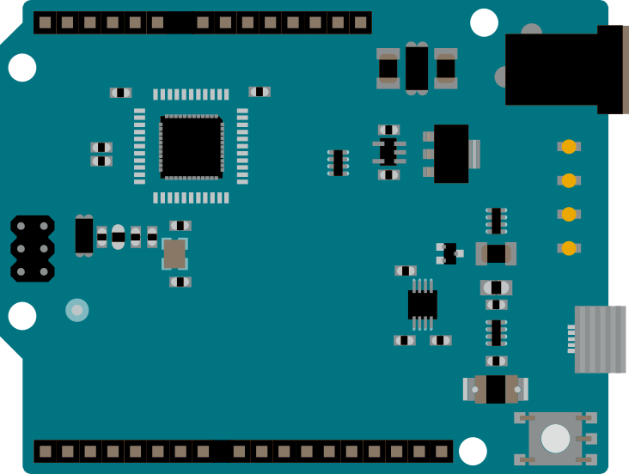

The Arduino Leonardo is a microcontroller board based on the ATmega32u4. It has 20 digital input/output pins (of which 7 can be used as PWM outputs and 12 as analog inputs), a 16 MHz crystal oscillator, a micro USB connection, a power jack, an ICSP header, and a reset button. It contains everything needed to support the microcontroller; simply connect it to a computer with a USB cable or power it with a AC-to-DC adapter or battery to get started.

IMG_256

**ATmega32U4**

The high Performance, low power AVR® 8-bit microcontroller.

IMG_257

**Built-in USB communication**

The ATmega32U4 has built-in USB communication that allows the Micro to appear as a mouse/keyboard on your machine.

IMG_258

**Battery Connector**

The Arduino Leonardo features a barrel plug connector, that works great with a standard 9V battery.

IMG_259

**EEPROM**

The ATmega32U4 features 1kb of EEPROM, a memory which is not erased when powered off.

